**Name: _______________________________________ Partners: ________________________________**

**Python Activity 2: Input and Variables**

|  |
| --- |
| **Learning Objectives**  Students will be able to:  *Content:*   * Explain how to input data using Python * Explain the meaning and purpose of a variable * Determine if a variable name is valid * Explain concatenation and the use of “+”   *Process:*   * Create **input** statements in Python * Create *Python* code that prompts the user for data and stores it in a variable * Create valid and good variable names   **Prior Knowledge**   * Material covered in Activity 1 |

**Critical Thinking Questions:**

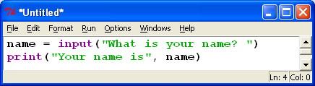

1. Enter and execute the Python program. What is printed on the screen when the Python program is executed?

_________________________________My Name is exclaimed as “Your name X” ________________________________________________

_________________________________________________________________________________

|  |
| --- |
| **FYI: input() and print()** are ***functions*** in Python. |

1. Examine the first line of Python program: **name = input(“What is your name? ”)**

a. What appears on the screen when this line of code is executed?

_________________________________What is your name? _____________________________________________

|  |
| --- |
| **FYI:** The words that appear on the screen and tell the user what to enter are known as a ***prompt***. |

|  |
| --- |
| **FYI: name = input(“What is your name? ”)**  The word **name** in the Python code is a ***variable*** *– a name given to a memory location used to store data.* |

b. What happens to the data the user entered?

____________________What is your name? Stefano

Your name is Stefano __________________________________________________________

3. Explain the errors that occur when you execute each of the following lines of Python code.

a. name? = input(“What is your name?”)

_______________________invalid syntax _______________________________________________________

b. your name = input(“What is your name?”)

______________________invalid syntax ________________________________________________________

c. 1st_name = input(“What is your name?”)

______________________________invalid syntax ________________________________________________

d. from = input(“Where were you born?”)

_____________________invalid syntax _________________________________________________________

4. Examine the errors that occurred when executing the lines of code in question 3. Then examine the following lines of valid code.

name2 = input(“What is your name?”)

your_name = input(“What is your name?”)

yourName = input(“What is your name?”)

List the rules that you need to follow to create a valid ***variable*** name.

_______________The following from question three do not work as they are do not create inputs with numerial value (unlike name2,your_name, yourName) and you need to make sure that the variable name has the actual word name in it without ANY spaces. ________________________________________________________________

________________________________________________________________________________

________________________________________________________________________________

5. Are the following variable names **valid**? Are they **good** names? Why or why not?

|  |  |
| --- | --- |
| **Variable name** | **Comments about variable name** |
| price | GOOD |
| costoffirstitem | Needs camelcases and/or underscores |
| Ic | Has Reverse camelCase and is bad. |
| firstName | GREAT! Has camelcase |

6. Execute the following lines of code. Is the output what you would expect? Why or why not?

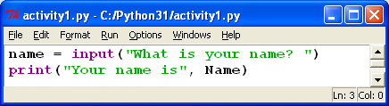 ___________Yes! It goes through with

A string literal and allows itself to allow user input

Then printing said output correctly when given input

From the user._____________________

________________________________

________________________________

________________________________

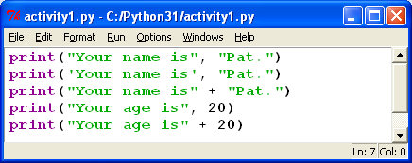

7. Use the following set of Python statements to answer the questions below.

a. State the output for each of line of code.

__________________________________________________________________________________________________________________________________________________________________

__________________________________________________________________________________________________________________________________________________________________

_________________________________________________________________________________

b. How are the first two print statements different? Does the difference affect the output?

_________________________________________________________________________________

c. Notice that some statements include a comma (,) between the two literals being printed and some statements use a “+”. Do they produce the same output? ____________________

d. Explain the purpose of the comma. _________________________________________________

_________________________________________________________________________________

e. Why does the last print statement crash the program? What would you do to correct it?

_________________________________________________________________________________

_________________________________________________________________________________

|  |
| --- |
| **FYI:** “+” **concatenates** two strings. The strings can be string literals or a variable containing string literals. |

8. State what is displayed on the screen when the following program is executed:

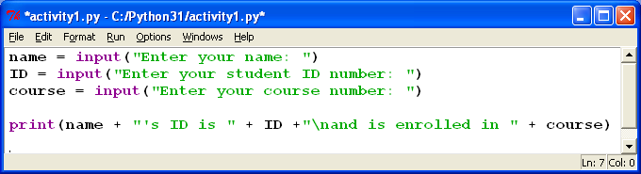

__________________________________________________________________________________________________________________________________________________________________

_________________________________________________________________________________

_________________________________________________________________________________

**9.** What caused the output in the print statement in question 8 to be printed on more than one line?

_________________________________________________________________________________

**Application Questions: Use the Python Interpreter to input your code and check your work**

1. State a good variable name for an employee’s ID number. __________________________________

2. Write a line of Python code that prompts the user for the name of their favorite ice cream and stores it in a valid variable name. __________________________________________________________

3. **Crazy Sentence Program**. Create a program that prompts the user for the name of an animal, a color, the name of a vehicle, and the name of a city. Then print a sentence that contains the user input in the following order. Include the additional words in the sample output as part of your output. Example: Assume the user enters the words: tiger, green, motorcycle, and Wildwood. The output would be: ***The* green tiger *drove the* motorcycle *to* Wildwood.**

__________________________________________________________________________________________________________________________________________________________________

_________________________________________________________________________________

_________________________________________________________________________________

__________________________________________________________________________________________________________________________________________________________________